Cody Do

105140467

Smallberg | 3C

Homework 5 Report

1a.

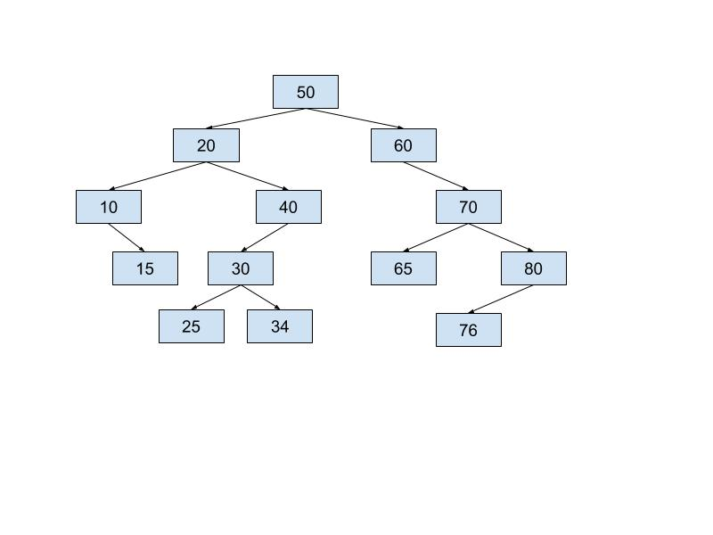

1b.

In-Order: 10, 15, 20, 25, 30, 34, 40, 50, 60, 65, 70, 76, 80

Pre-Order: 50, 20, 10, 15, 40, 30, 25, 34, 60, 70, 65, 80, 76

Post-Order: 15, 10, 25, 34, 30, 40, 20, 65, 76, 80, 70, 60, 50

1c.

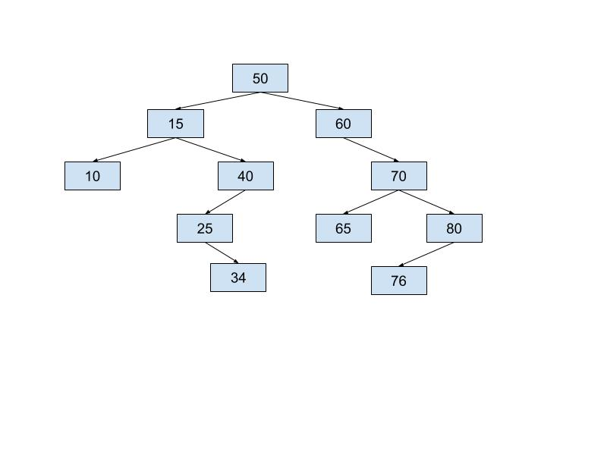

2a.

struct Node {

int data;

Node \*parent, \*leftChild, \*rightChild;

};

2b.

void insert(int x, Node\* root) {

if (root == nullptr)

root = new Node with value x

return;

Node\* curr = root;

for(;;) //Infinite loop that cycles through until the node is added

{

if (\*curr == x)

return; //The value exists already

if (x < \*curr) //If our value is less than what curr points to

{

if (curr == nullptr)

new node with value x at curr’s left node

return;

else

set curr to point to left’s child

}

else //If our value is greater than what curr points to

{

if (curr == nullptr)

new node with value x at curr’s right node

return;

else

set curr to point to right’s child

}

}

}

3a.

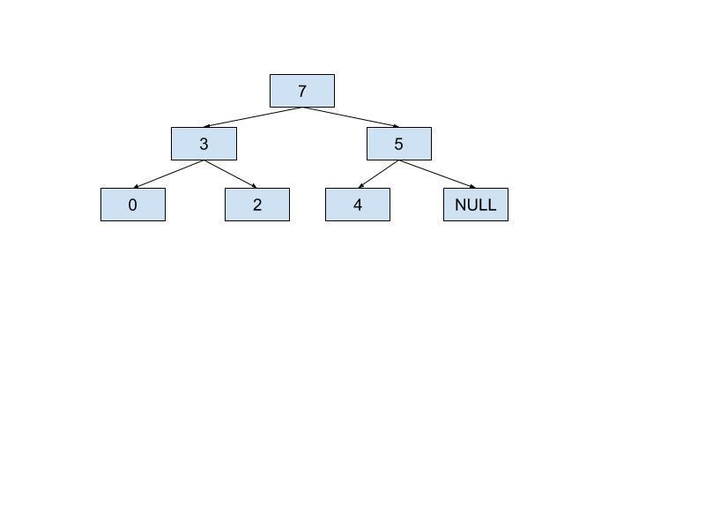

3b.

*Array Position:* [0] [1] [2] [3] [4] [5]

*Value in Array:* [7] [3] [5] [0] [2] [4]

3c.

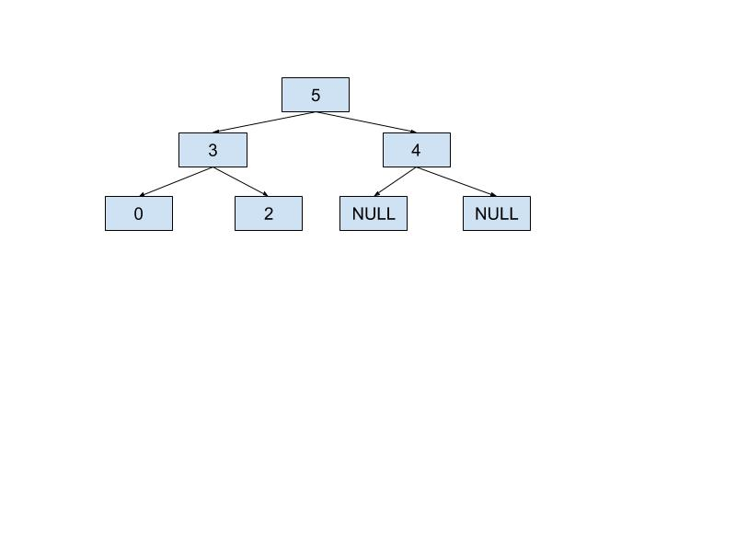

*Array Position:* [0] [1] [2] [3] [4]

*Value in Array:* [5] [3] [4] [0] [2]

4a. C + S

4b. logC + S

4c. logC + logS

4d. 1 + logS = logS

4e. 1

4f. logC + S

4g. SlogS

4h. C\*logS

5b. It was very important to have the second string parameter as it acted as a container for the string to be output to the console. Every time the function travels along one subclass branch, it can pass on its pathway string to the next subclass through a recursive call on itself with the new, modified string as input. This allows the function to output the proper pathway from beginning base class to each final subclass. It would have been impossible to implement this function without the string input parameter as there would be no way to suitable pass path string information from one function call to the next. In a one-parameter function, each recursive call would essentially be starting with a new, empty string.